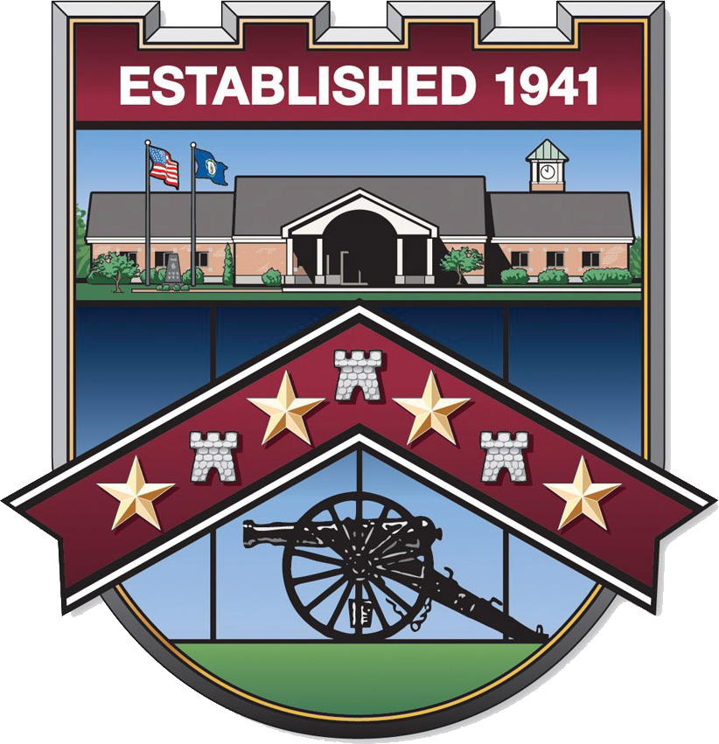
City of Fort Wright
409 Kyles Lane | Fort Wright, KY 41011 | www.fortwrightky.gov | 859.331.1700

City of Fort Wright Council Meeting Agenda
Wednesday – April 1st, 2026
6:00 p.m.

CALL TO ORDER:

PLEDGE OF ALLEGIANCE/PRAYER:

CITIZEN COMMENTS/GUESTS:

MINUTES: ·Minutes from the March 4th, 2026 City Council Meeting.
·Minutes from the March 18th, 2026 City Caucus Meeting.

UNFINISHED BUSINESS: ·Ambulance Bid Update.
·Walmart Drone Delivery Service Update.
·Qualified Manufactured Home Regulation Requirements.

NEW BUSINESS ·Municipal Order 01-2026 disposing of surplus property.
·Law Enforcement Navigator Program Update.
·Legislative Updates, Discussions, and/or Actions.

COMMITTEE REPORTS:

CAO REPORT:

DEPARTMENT REPORTS: Administration Police Department
Finance Public Works
Fire/ALS Department Building & Zoning
Legal Counsel Engineering

SPECIAL ANNOUNCEMENTS: Employee Recognitions/Special Thank You’s.

COUNCIL COMMENTS:

EXECUTIVE SESSION:

